
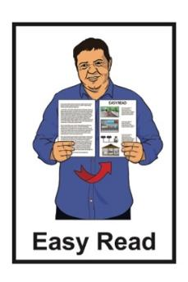

Have your say about the

Digital Accessibility Standard: Easy Read survey
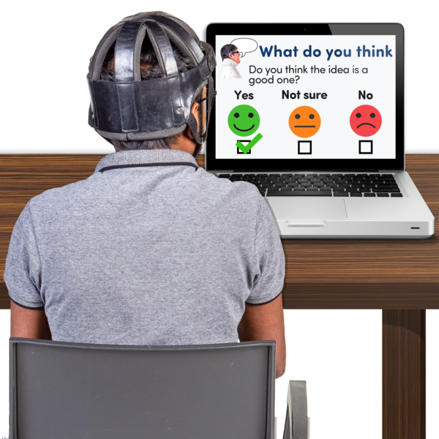

Published: July 2026

Before you start

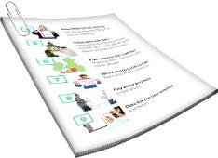
This is a long document.


It can be hard for some people to read a document this long.

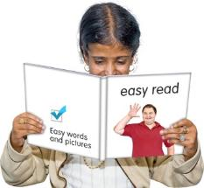
Some things you can do to make it easier are:
read it a few pages at a time
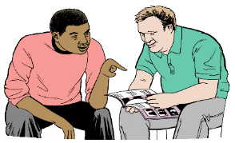
set aside some quiet time to look at it
have someone read it with you to support you to understand it.

What is in here


Page number:

About this Easy Read 4
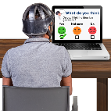

About the survey 7


Question 1: Contact information 9
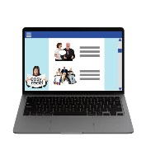

Questions 2 to 5: Accessibility Statements 12
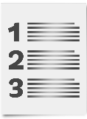

Question 6: The new DAS 22
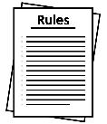

Questions 7 - Exceptions 24

Page number:


Questions 8 - Support 27


Question 9 - Other feedback 33


Question 10 - About you 36

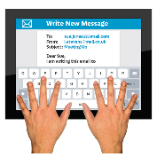
Send us your feedback 38

What happens next 40

About this Easy Read

This Easy Read survey is from the Government Digital Delivery Agency.
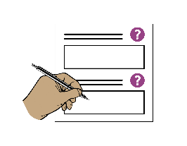

A survey is a set of questions to find out what you think about something.

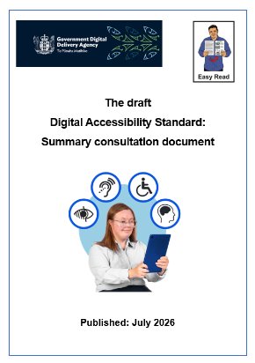
Before you start this survey you first need to read the Easy Read called:

The Digital Accessibility Standard: Summary consultation document


That Easy Read summary is on this website:

www.digital.govt.nz/das#alt

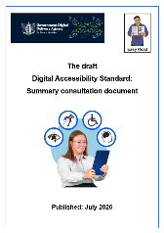
That Easy Read will explain some the ideas / hard words that are in this Easy Read.

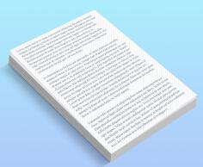
When you see the words
we / us / our it means the Government Digital Development Agency.

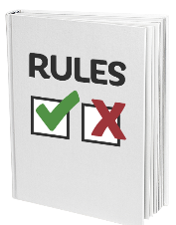
This Easy Read survey is a way to find out what you think about the draft Digital Accessibility Standard.
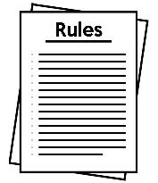

The Digital Accessibility Standard:
- is a new set of rules about digital accessibility
and

- will work to make sure all Government digital information and services are accessible for disabled people.

Here accessibility means digital tools should be able to be used by everyone including disabled people.

In this Easy Read we call the Digital Accessibility Standard DAS in this document.

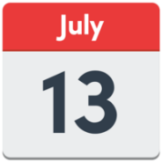
You can have you say about the draft DAS from:
Monday 13 July
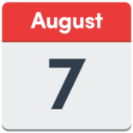
to
Friday 7 August 2026.

About the survey

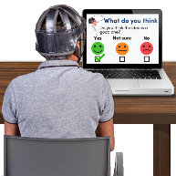
We want to find out what you think about the draft DAS.

There are 2 surveys for you to pick from.

- Online survey which has
18 questions.

You can find that online survey at:
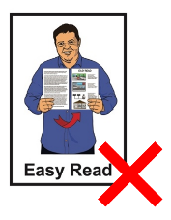
https://tinyurl.com/DASSurveyLink

The online survey is not in Easy Read.
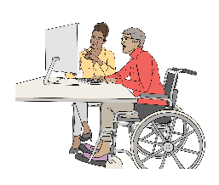

It is okay to ask someone to support you to do online survey
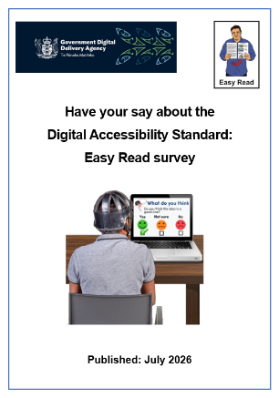
- This Easy Read survey which is shorter with 10 questions.

You can print out this Easy Read to fill it in.

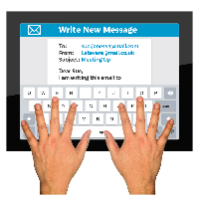
If you need a printed Easy Read survey sent to you email us at:
web.standards@gdda.govt.nz


When you have finished filling in the survey you can email or post it to us.
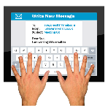
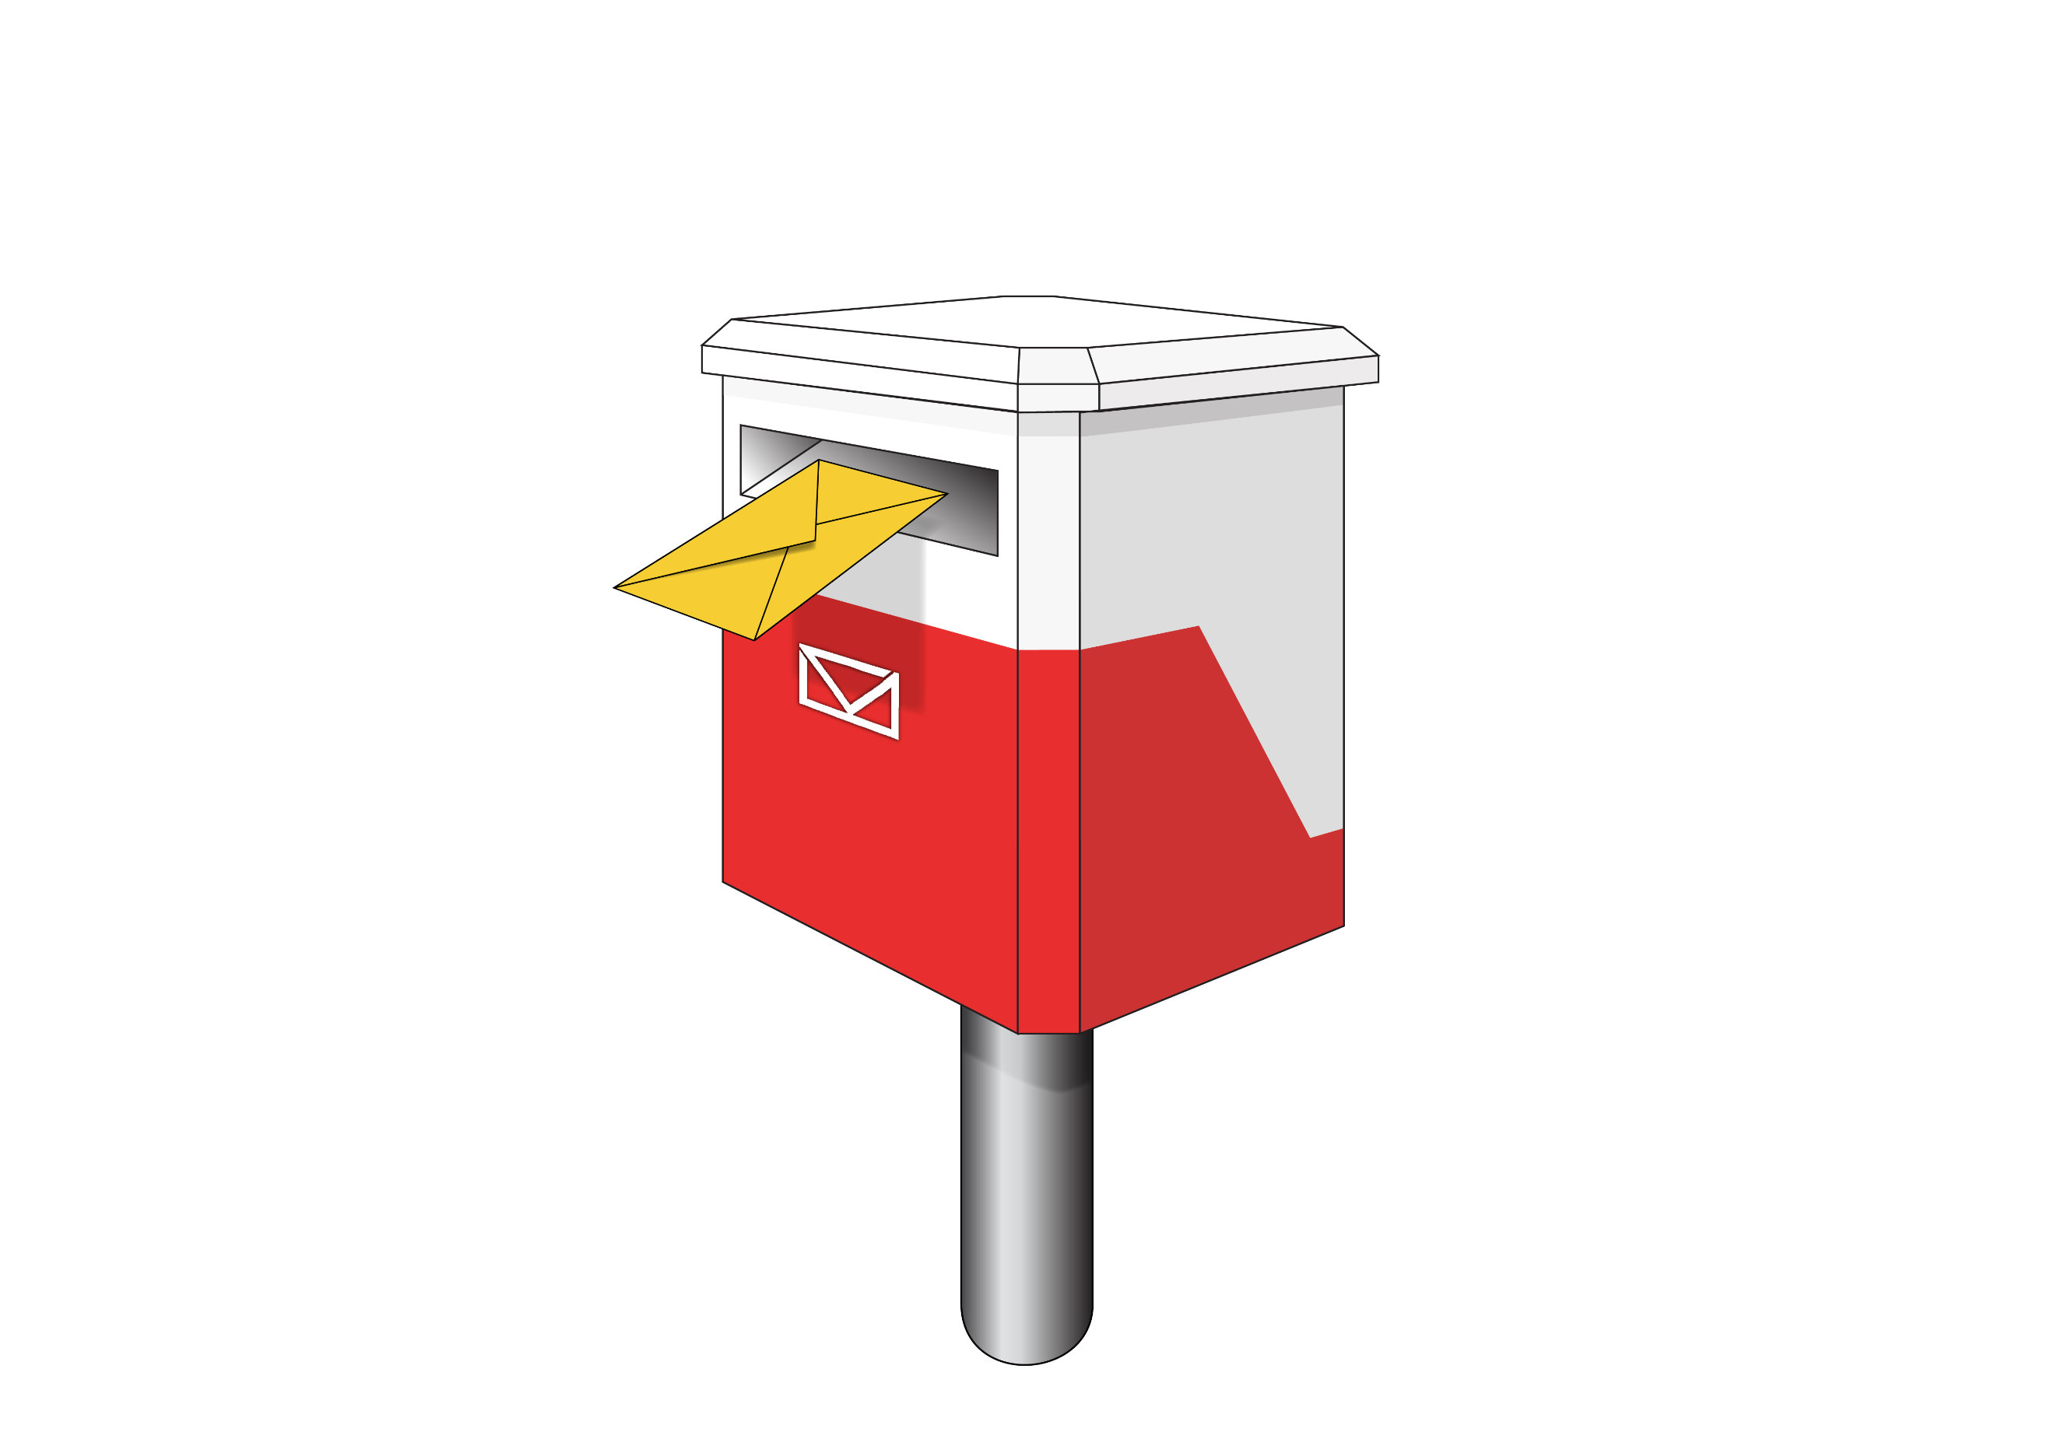

We tell you where to send your survey to us on page 38.

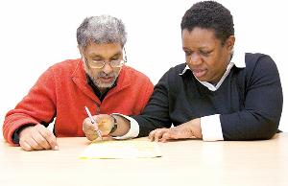
You can ask someone to support you to do this survey.

Question 1: Contact information

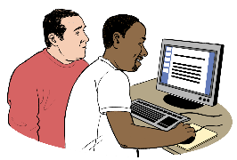
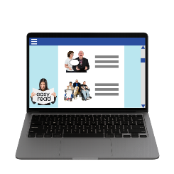
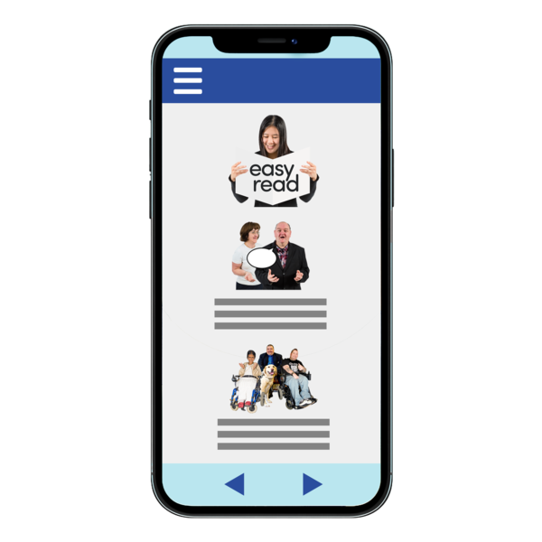
Government organisations need to let people know how to contact them on their:
websites
mobile apps.

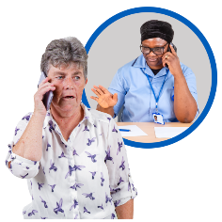
The contact information must be:
easy to understand
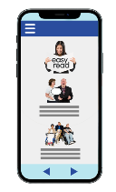
and
accessible.

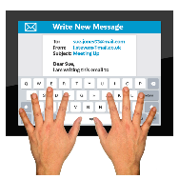
Government organisations should have more than 1 way for people to contact them.

- How do you like to contact a government organisation?
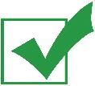
Tick the boxes next to the answers that are right for you:

phone call
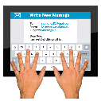
email


Seeflow / New Zealand Sign Language service

New Zealand Relay Service

online form
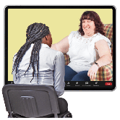
video call


text message / SMS

chatbot – when you talk to a computer online not a person

other:_________________
Please tell us why you made these choices for Question 1 in the box:

Questions 2 to 5: Accessibility statements

Accessibility statements are a part of a website or app to say how accessible it is.


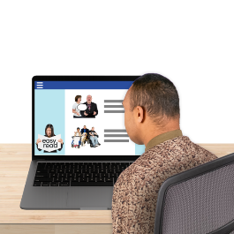
Government websites and mobile apps for the public need to say how accessible they are.

This information must be:
easy to understand
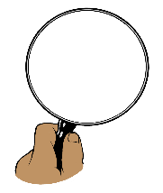
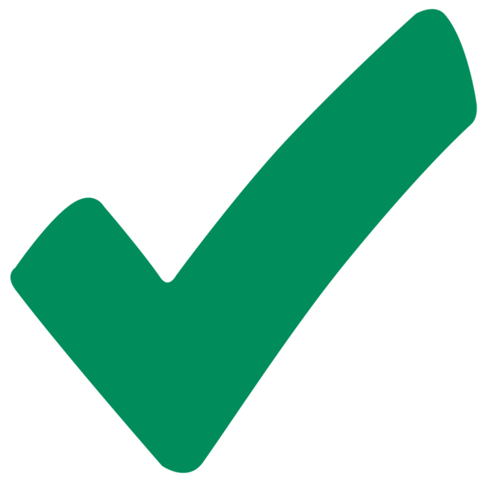
current / up to date
easy to find.

It must tell people using them:
if there are any known accessibility problems
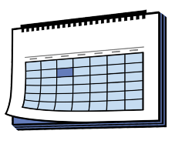
when any problems are likely to be fixed

what ways people can:
- give feedback about accessibility
- ask for support.

- Should all Government websites and mobile apps have an accessibility statement?
Tick the boxes next to the answer that are right for you:

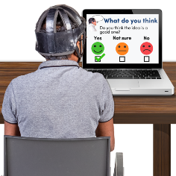
yes

no

unsure.

Please tell us why you made this choice in the box:

- What should be in an accessibility statement?
Tick the boxes next to the answers that are right for you:
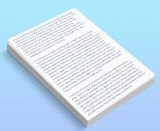
it should say something about the DAS

it should have a link to the accessibility plan of the organisation

it should say what accessibility problems they know about such as:
hard to read documents
digital tools made by other places that are not accessible.
There are more tick boxes on the next page.

- What should be in an accessibility statement?
Tick the boxes next to the answers that are right for you:

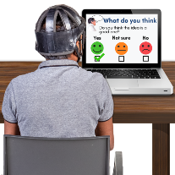
it should have contact details to:
give feedback about accessibility
ask for support
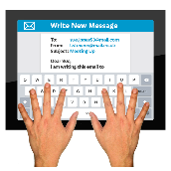
have information about how the organisation will get back to you if you contact them.

other – write your answer in the box

Please tell us why you made these choices for Question 3 in the box:

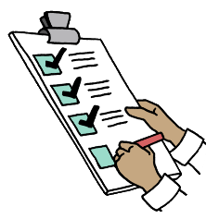
- Should all Government accessibility statements follow the same template?

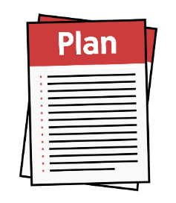
Here a template is a document that:
works as a starting point to make an accessibility plan
guides what to have in an accessibility plan.

Tick the boxes next to the answer that are right for you:

yes

no

unsure.

Please tell us why you made these choice for Question 4 in the box:

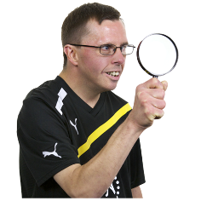
- Where would you expect to find accessibility statements on websites and apps?
Tick the boxes next to the answers that are right for you:
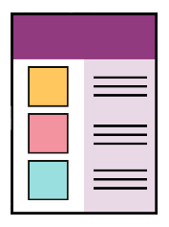
1 main accessibility statement for each Government agency for all its websites and mobile apps
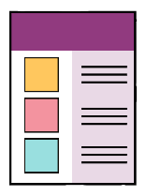
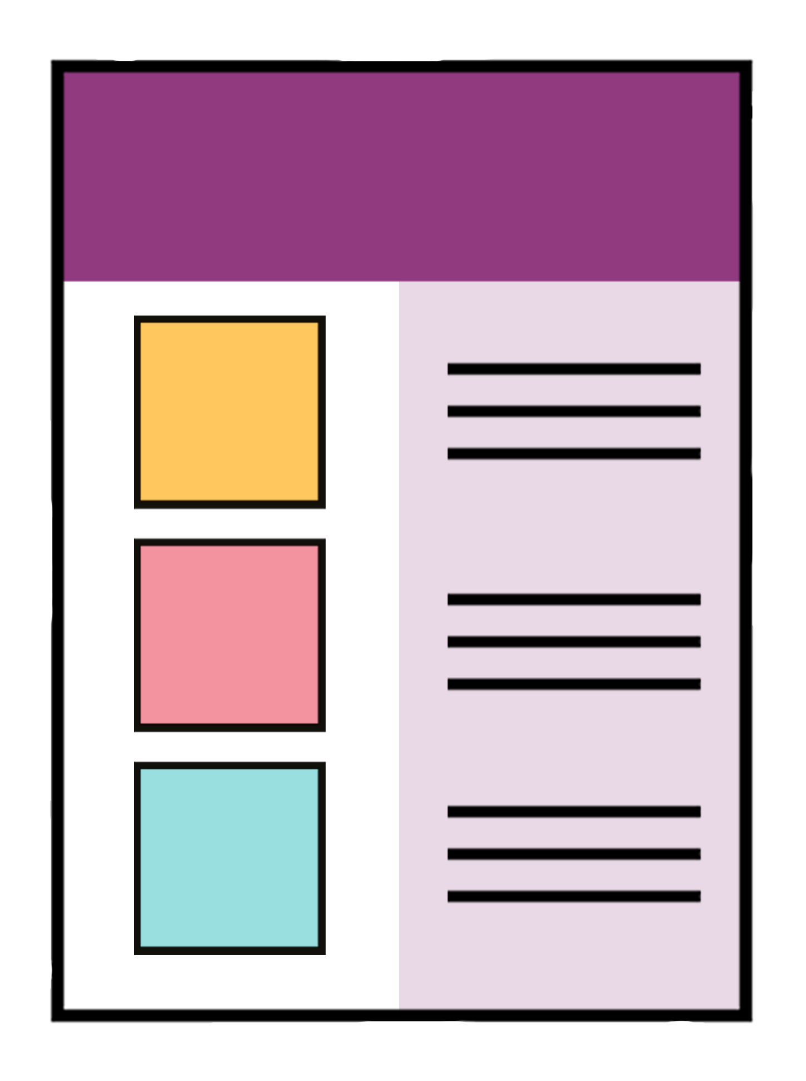

a separate accessibility statement for each website or mobile app

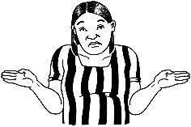
something else.

Please tell us why you made this choice for Question 5 in the box:

Question 6: The new DAS
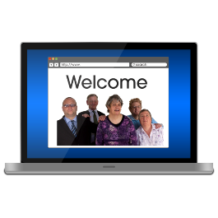

The Web Accessibility Standard is only for Government:
- websites
- web apps.

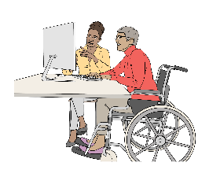
The Web Accessibility Standard is a set of rules about making sure Government websites can be used by disabled people.

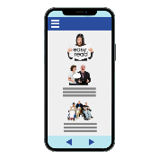
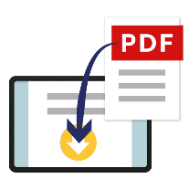
The new DAS could mean there are rules for other digital / online tools like:
mobile apps
PDF documents
emails.

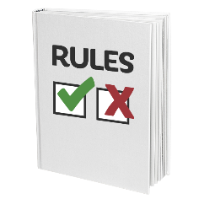
- Do you think the new DAS should also have accessibility rules for other digital / online tools?

Tick the boxes next to the answer that are right for you:

yes

no

unsure.

Please tell us why you made this choice for Question 6 in the box:

Question 7: Exceptions
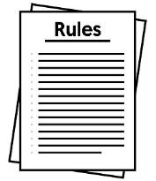

Exceptions means the times when the rules do not have to be followed.

Sometimes a Government organisation cannot follow all the DAS accessibility rules.


This might be because:

it costs too much money to make it accessible
- there is not enough time to make something accessible

- Government organisations should:
- tell people about exceptions
- keep a record about the exception

Tick the boxes next to the answer that are right


agree a lot

agree a little bit
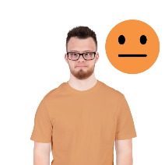

not sure

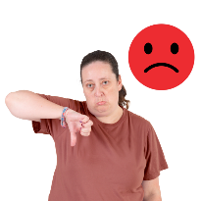
do not agree

do not agree at all

other.
Please tell us why you made this choice for Question 7 in the box

Question 8: Support

Good tools are needed to make sure the DAS can be followed by:

Government organisations
people delivering / who give digital services.

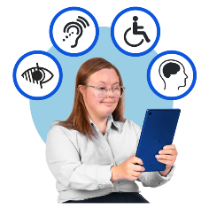
They need:
the right tools
knowledge about accessibility
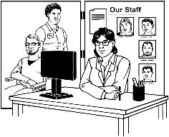
support to make their services accessible.

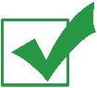
- What things do you think would support the Government to follow the new DAS?

You can tick up to 3 boxes for Question 8:

have a good working Accessibility Charter

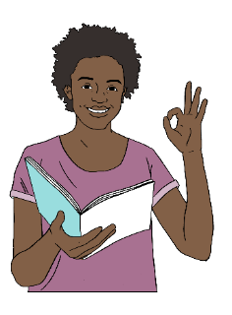
The Accessibility Charter is a document Government organisations sign to say:
they are working to making their services accessible
their information is accessible to everyone.

There are more tick boxes for Question 8 on the next page.

- What things do you think would support the Government to follow the new DAS?

You can tick up to 3 boxes for Question 8:


strong support from:

leadership
decision makers.
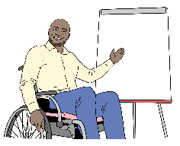

training for teams working on things to do with accessibility

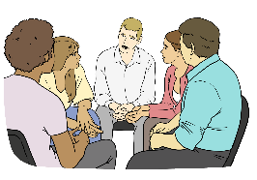
being able to ask an accessibility team for:

advice
support.

There are more tick boxes for Question 8 on the next page.
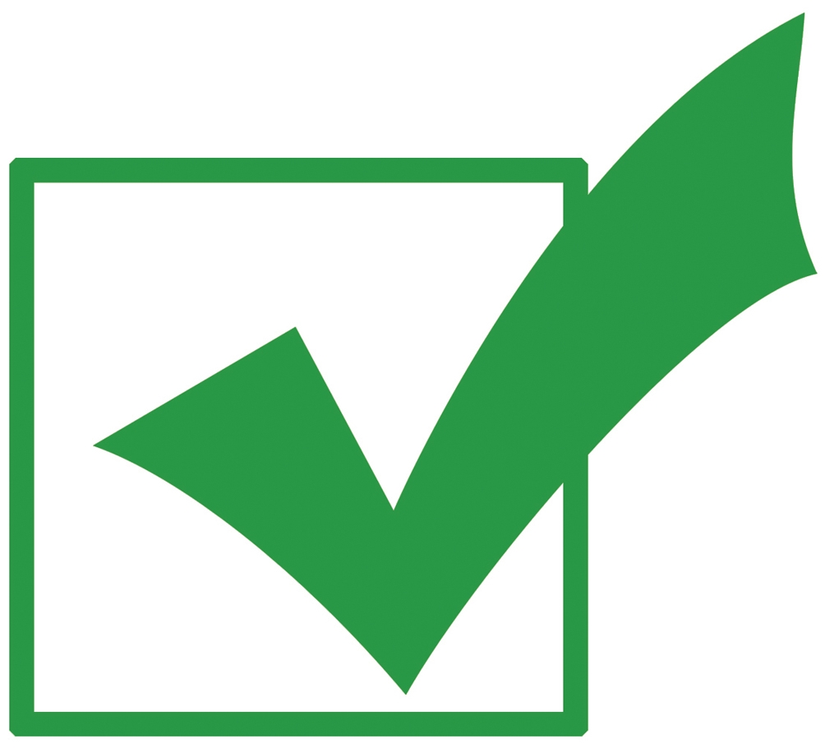
- What things do you think would support the Government to follow the new DAS?

You can tick up to 3 boxes for Question 8:

making knowing things about accessibility a job skill.

training for teams working on things to do with accessibility
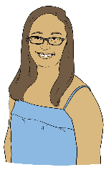

true stories to let people know what accessibility is

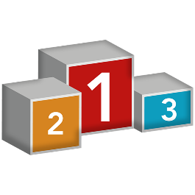
having a score that shows how well an organisation is doing on being accessible.

There are more tick boxes for Question 8 on the next page.
- What things do you think would support the Government to follow the new DAS?

You can tick up to 3 boxes for Question 8:
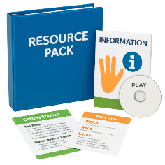
having a main place for accessibility resources / information

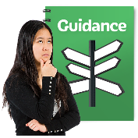

clear ideas on how an organisation can make accessibility part of how they work.
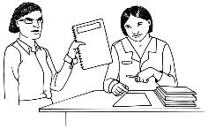
sharing information about accessibility with other Government agencies

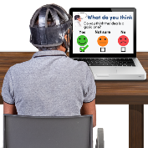
ways for disabled people to give feedback about services.

Please tell us why you made these choices for Question8 in the box.

Question 9: Other feedback
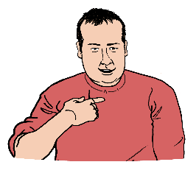

You can give feedback about the DAS in your own words.

A reminder you can read the Easy Read summary of the draft DAS at:

www.digital.govt.nz/das#alt

This will tell you about the draft DAS including:
what we are doing
why we are doing it.


- What changes would you like to be made in this draft DAS?

Why do you think these changes are needed?


Please tell us what you think in this box.

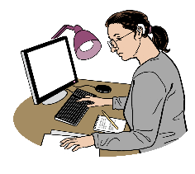
We may not be able to make all the changes you have told us about.

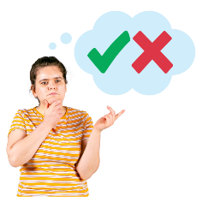
Your feedback will help us to make decisions about the DAS in the future.

Question 10: About you


We would like to find out some information about you.

- What answers best fit you?
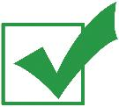
Tick the box that is right for you:


work for the Government

someone who makes digital tools


disabled person.

There are more tick boxes for Question 10 on the next page

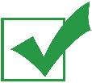
10. What answers best fit you?

Tick the box that is right for you:
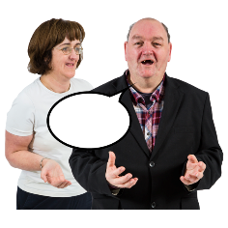

disability advocate / somebody who speaks up for disabled people.
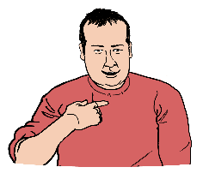

other – please put your answer in the box:

Send us your feedback
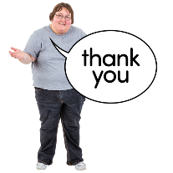

Thank you for taking the time to complete this survey.

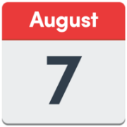
Please send us your survey answers by Friday 7 August 2026.

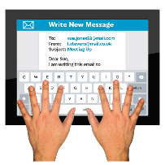
You can send us feedback by emailing your survey to us at:
web.standards@gdda.govt.nz
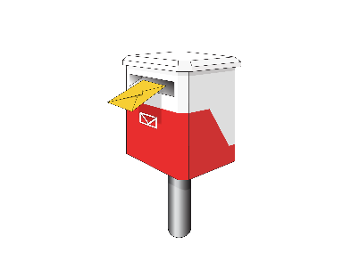

You can also post your survey answers to:

Web Standards Team
Government Digital Delivery Agency
Public Service Commission
PO Box 329
Wellington 6140
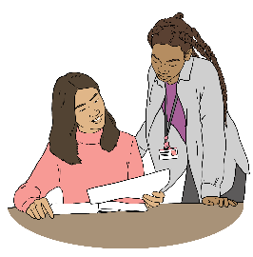
Information you share with us will be treated with:
care
respect.

You can find more about how information is used by visiting our privacy statement page at this website:

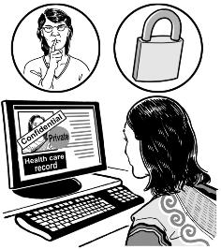
www.digital.govt.nz/home/about-digital-govt-nz/privacy

Here privacy is keeping information about you safe.

This website is not in Easy Read.

What happens next


After the survey closes we will look carefully at all the feedback we have been sent.

This feedback will support us to make the final DAS.

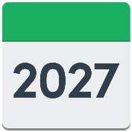
In early 2027 we will publish:
the final DAS
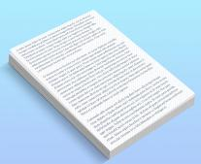
a document telling you about why the decisions were made.


There is more information about the DAS at this website:

https://www.digital.govt.nz/das

This information has been written by the Government Digital Delivery Agency –
Te Pūnaha Matihiko.

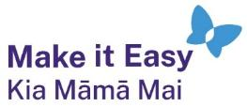
It has been translated into Easy Read by the Make it Easy Kia Māmā Mai service of People First New Zealand Ngā Tāngata Tuatahi.

The ideas in this document are not the ideas of People First New Zealand Ngā Tāngata Tuatahi.

All images used in this Easy Read document are subject to copyright rules and cannot be used without permission.

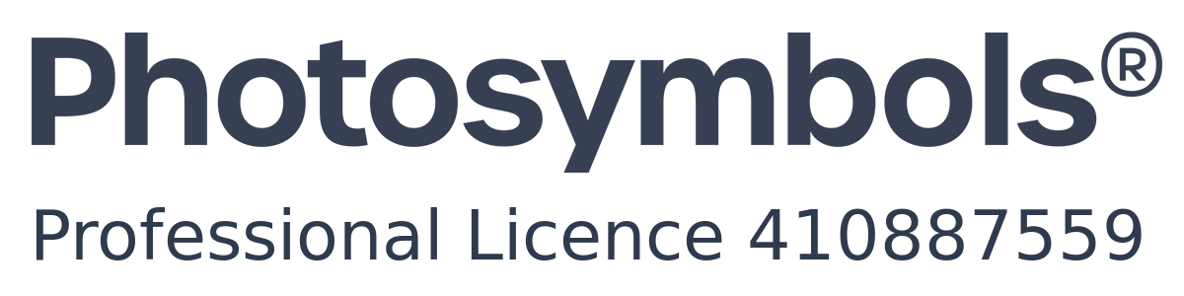
Make it Easy uses images from:


- Photosymbols

- Change Images


- Huriana Kopeke-Te Aho

- SGC Image Works

- T Wood


- Studio Rebeko

- Inga Kramer.

