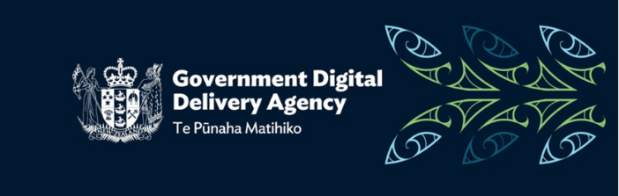
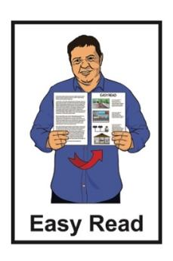

The draft

Digital Accessibility Standard:
Summary consultation document
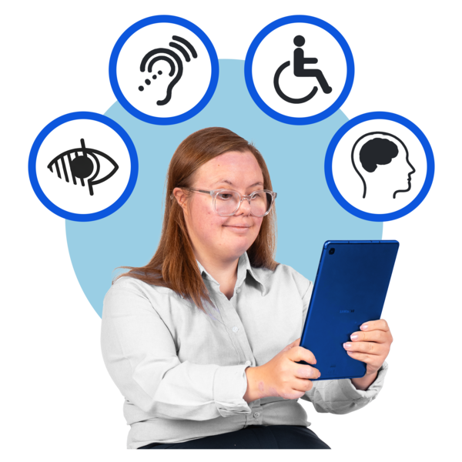

Published: July 2026

Before you start

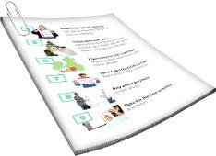
This is a long document.

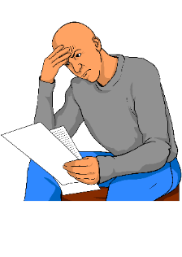
It can be hard for some people to read a document this long.

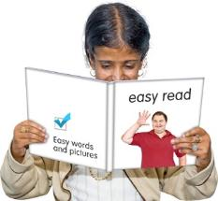
Some things you can do to make it easier are:
read it a few pages at a time
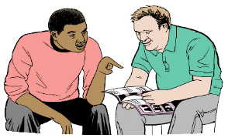
set aside some quiet time to look at it
have someone read it with you to support you to understand it.

What is in here

Page number:
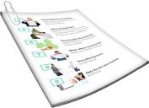

About this Easy Read 3
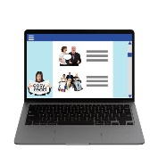

About the Digital Accessibility
Standard 7
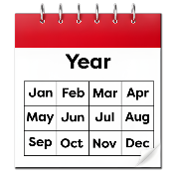

When things happen 10

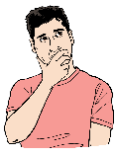
Why we need a new standard 13

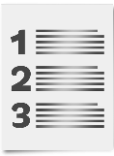
Summary of the
Disability Accessibility Standard 20


How to have your say 35

About this Easy Read

This Easy Read document is from the Government Digital Delivery Agency.


The Government Digital Delivery Agency supports the Public Service to use more digital technology.
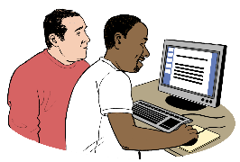

This supports New Zealanders to use Government services.

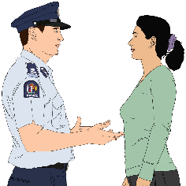
The Public Service means the parts of the Government that provide everyday services to New Zealanders like:

the police
healthcare like hospitals.

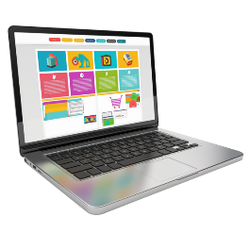
Here digital technology means all the different things that have been created / made to be able to do things online using digital tools.

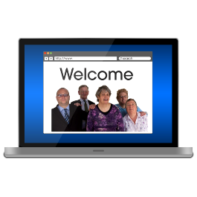
Digital tools are things that use digital technology like:
apps

websites.

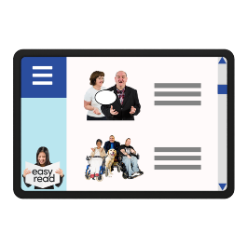
Digital tools support you to do things online using things like your:
computer
laptop
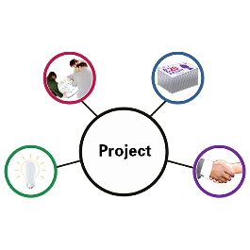
phone
iPad / tablet.

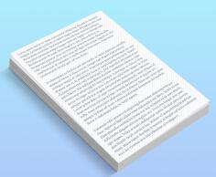
When you see the words
we / us / our it means the Government Digital Development Agency.

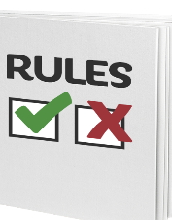
This Easy Read is about a new set of rules the Government will need to follow when using digital technology.

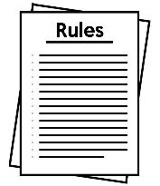
The Digital Accessibility Standard is:
a new set of rules about digital accessibility
and

will work to make sure all government digital information and services are accessible to disabled people.


Here accessibility means that digital tools should be able to be used by everyone including disabled people.

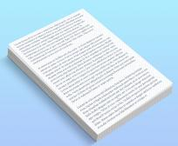
We call the Digital Accessibility Standard DAS in this document.

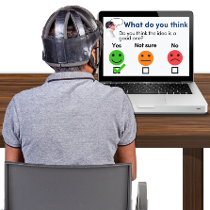
We want to find out what you think about the draft DAS.

On pages 35 to 37 you can find information about how you can have your say about the draft DAS.

About the Disability Accessibility Standard

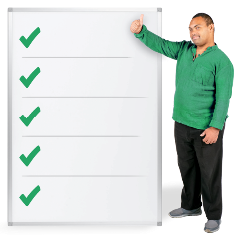
The Government has rules about making websites accessible for disabled people.


These rules are called the
New Zealand Government Web Standards.


The New Zealand Government Web Standards is made up of 2 sets of rules called the:

Web Accessibility Standard
and
Web Usability Standard.

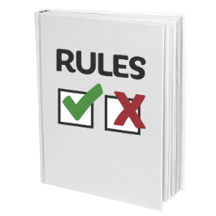
Here a standard is a set of rules people should follow when they are:
doing something like building a website
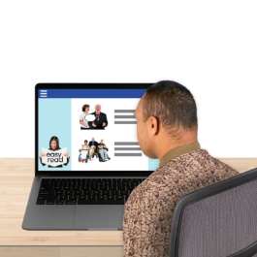
managing something like a website

Standards support digital technology to be accessible to everyone.

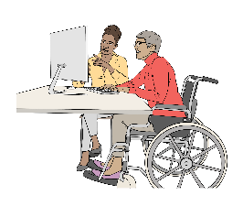
The Web Accessibility Standard is a set of rules about making sure Government websites can be used by disabled people.

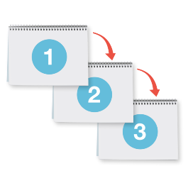
The Web Usability Standard is a set of rules to make sure Government websites have the right things like contact information.

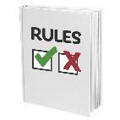
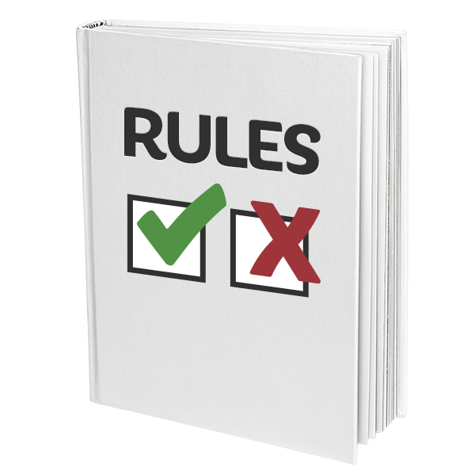
A new DAS will replace the Web Accessibility Standard in early 2027.

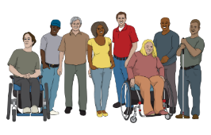
The DAS will be made with the support of:

disabled people
people who make digital Government:
- information
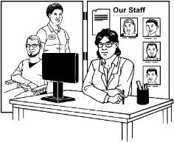
and
- services.

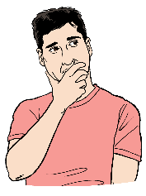
We want to find out what you think about the draft DAS.

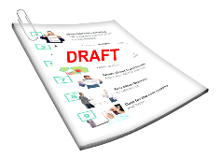
Here draft means writing something for the first time.

There will be changes before the DAS is finished.

When things happen


We have made a draft of the DAS to be used for public consultation.

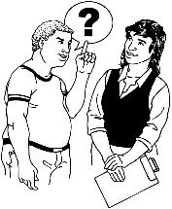
Here public consultation means we will ask people what they think about our draft DAS.

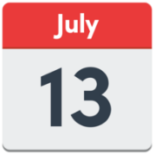
We will have our public
consultation from:
Monday 13 July
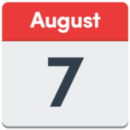
to
Friday 7 August 2026.

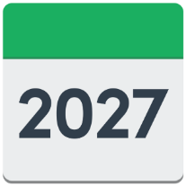
In early 2027 the:
consultation summary will be published

support programmes will be published
new DAS will be published.

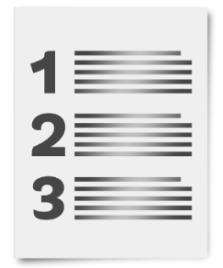
A summary:
- is shorter than the main
document
tells you the main ideas.


Here published means the DAS will be able to be:
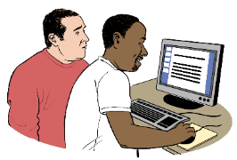
seen by everyone
read by everyone.

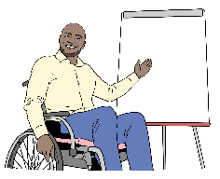
Here support programmes are ways to support people to use the DAS like having training sessions.


We will also make a document to explain things about the DAS like:
how decisions were made
why decisions were made.
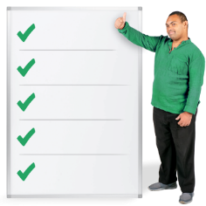

The DAS will start to be used sometime after it has been published.


You can find out more about the public consultation at this website:

https://www.digital.govt.nz/das/consultation
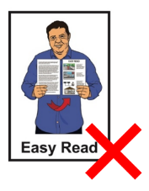

This website is not in Easy Read.

Why we need a new standard


All government digital information and services must be accessible to disabled people.

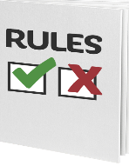
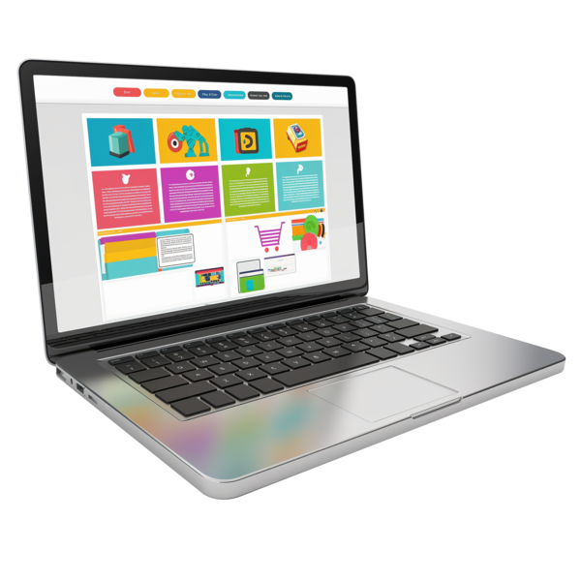
The standard we use now only has rules for:
websites
web apps.

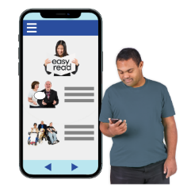
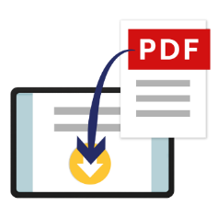
We need new rules to make sure all Government digital technologies are accessible like:
websites
mobile apps
electronic documents like PDFs.
We also need new rules to make sure all Government digital technologies are accessible like:
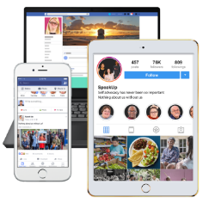
online forms
online services
Government information online.


All Government information and communication technology / ICT will have to follow the DAS.
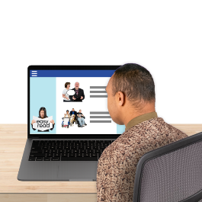

Information and communication technology / ICT means digital tools people use to get:

information
services.

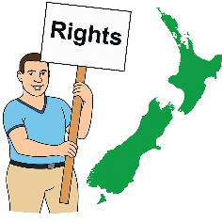
Doing this will show the Government is following the:
Human Rights Act

and
United Nations Convention on the Rights of Persons with Disabilities.

The Human Rights Act is the law that protects the human rights of New Zealand.

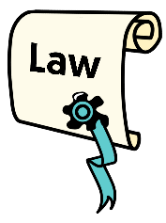
A law is a rule made by the Government that everyone must follow.

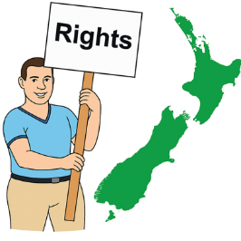

Human rights are things that the
law says every person should:
have

be able to do.

Rights are things like:
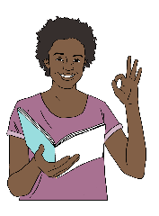
having a safe place to live
getting information in a way people can understand.

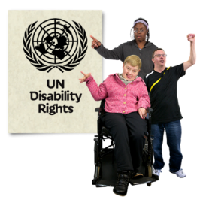
The United Nations Convention on the Rights of Persons with Disabilities is a law lots of countries have agreed to.

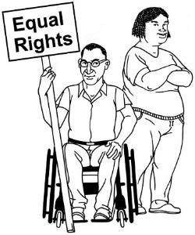
The United Nations Convention on the Rights of Persons with
Disabilities is also called the UNCRPD.

It says what governments must do to make sure disabled people get the same rights as everybody else.

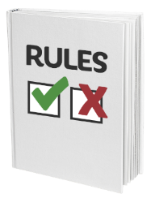
The DAS will support Government agencies to make digital technologies accessible by making the rules clear for digital accessibility.

The Government will support government agencies to follow what the DAS says.

Support for government agencies


We are planning ways to support government agencies to:
make digital accessibility better
follow what the DAS says.


We will work with
Whaikaha – Ministry of Disabled People to do this.


What will happen to the Web Usability Standard?

The Web Usability Standard will be used to guide people when using the Digital Service Design Standard.

The Digital Service Design Standard lets people know what
they need to think about if they are:
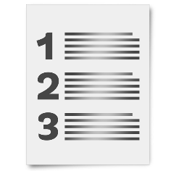
designing / making Government digital services
providing digital services for the Government.

You can find out more about the Digital Service Design Standard at this website:

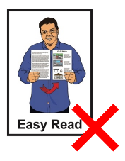
www.digital.govt.nz/digital-service-design-standard

This website is not in Easy Read.

Summary of the
Disability Accessibility Standard

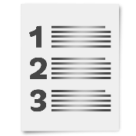
This part of the document is a summary of the draft DAS.

Reason for the DAS

The DAS will make sure disabled people can access all Government digital:
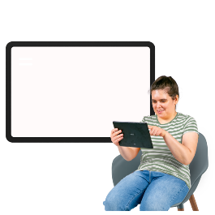

information
and
services.

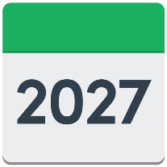
Who must follow the DAS

The new DAS will:
start in early 2027

replace the Web Accessibility Standard 1.2.

Mandated organisations must follow what the new DAS says.



Here mandated organisations are the Government organisations that have to follow the DAS.

Some organisations in the
Public Service:
do not have to follow the DAS
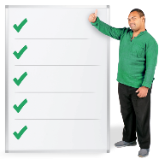
but
should follow the DAS when they can.

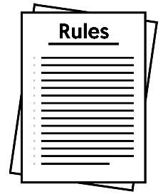
Rules for digital products and services

This is about the ICT accessibility that mandated organisations are responsible for.
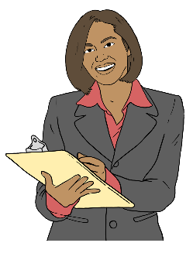

Here responsible means looking after something like a website to make sure it is doing what it is meant to.

These ICT products and services are things like:
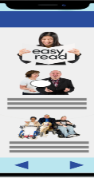
websites
mobile apps
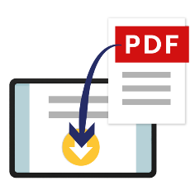
non-web documents like:
- PDFs
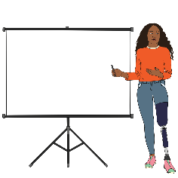
- letters
- emails
- spreadsheets.

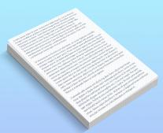
Non-web documents are digital documents that:
are not part of a web page
need to be opened to read.

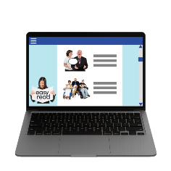
These ICT products and services are also about:
software like:


- the operating system / main software on your computer like Windows
- a web browser like Google Chrome
hardware like:
- laptops
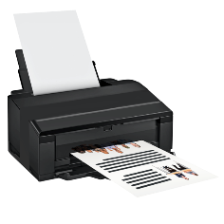
- phones
- printers
- kiosks.
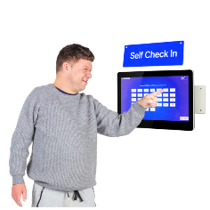

Here kiosks are small places in a public area where you use a digital service.
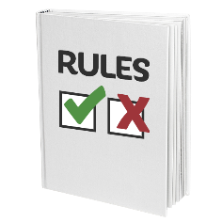
The rules should be followed when the DAS starts in early 2027 for all new ICT products and services.

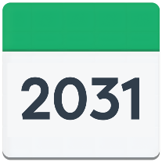
ICT products and services being used need to follow the DAS by 2031.

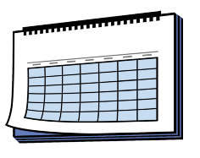
This date may be different for some products and services.

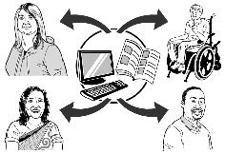

The DAS rules do not have to be followed for things like:
drafts that are not ready to be shared
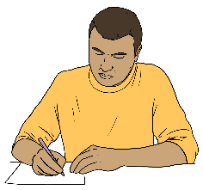
notes that were not meant to be shared
some ICT tools not controlled by the Government agency.
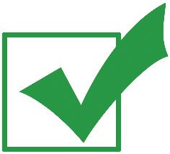
All Government digital products and services must meet the European accessibility standard called EN 301 549.
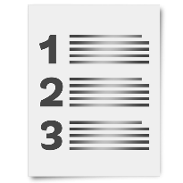

An accessibility statement is needed for all public:
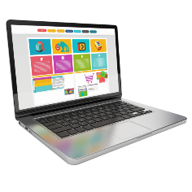
web pages
mobile apps.

An accessibility statement tells you about the accessibility of the:

website
app.

Accessibility statements say things about:

how accessible something is
if there are problems
how to give feedback
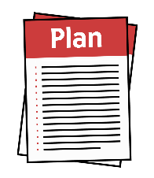
plans to make it better.

Accessibility statements must be:

easy to find
labelled / given the right name.

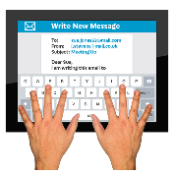
Government websites and apps should also have how to contact them like:
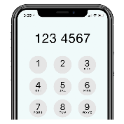
an email address
a phone number

a link to NZ Relay Service
other ways to get support.

Contact information must be:
easy to find on the
home page / main screen

clearly labelled like for example:
Contact us.

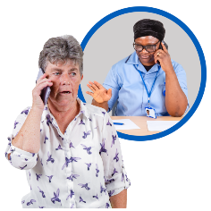
All public non-web documents must have information about how to contact the Government agency that published the document.

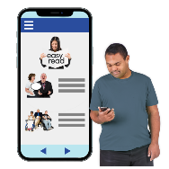
Public information should be published as accessible web pages before they are:
put on a mobile app
made into documents like PDFs.


What mandated organisations must do

Mandated organisations will need to plan to make sure all their digital products and services are accessible.
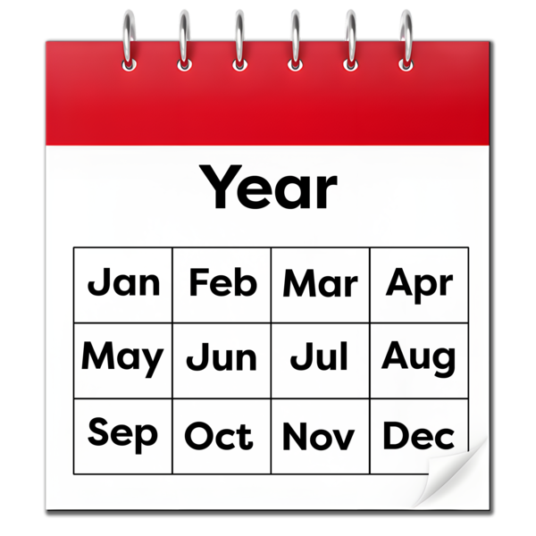

Each mandated organisation must have a 3-year plan.


The plan must have things about:
how they are making progress on improving accessibility

any exceptions
plans to fix the exceptions.

Here exceptions means the times when the rules do not have to be followed.
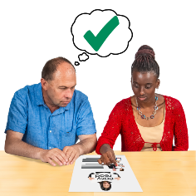
The plan must:
be checked every year
be changed when it needs to be
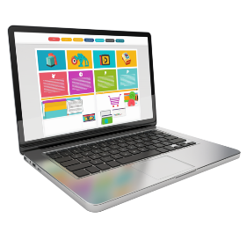
be published on a public website.

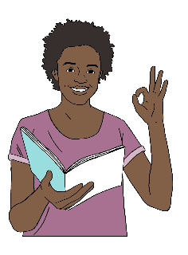
All online content / information must be written in plain language.

Plain language means writing in a clear way making it easy for most people to understand.

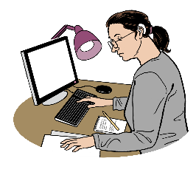
Organisations must test accessibility of their products and services like:
using different ways to make sure the product or service is accessible
getting disabled people to use them to find out if they are accessible.

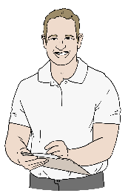
Organisations must also:
check accessibility regularly
report on accessibility when asked
work with the Government to test their ICT
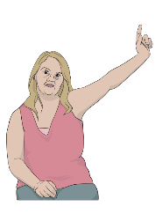
reply to questions about accessibility within 3 days
say when they will give a full answer to the question.

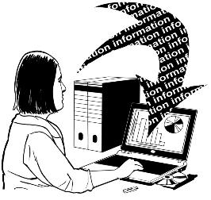
When testing the accessibility of products and services information needs to be kept about:
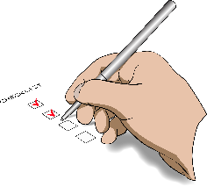
feedback people have made
actions / work done to fix accessibility problems.

When a mandated organisation buys ICT products from another place these must follow the DAS rules.

Exceptions

Exceptions are sometimes allowed when:
the DAS cannot be followed
or

when following the DAS would be very hard like costing a lot of money.

Organisations must keep records saying why:
there is an exception
the exception is needed.
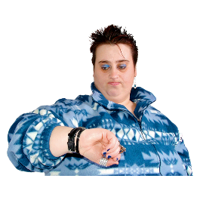
Exceptions can only be in place for a short time.


They must be checked over time to see if things have changed.

How to have your say

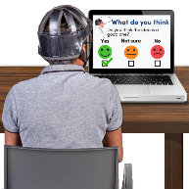
We want to find out what you think about the draft DAS.


Your feedback will support us to make the final DAS to work for disabled people.

There are 2 surveys for you to pick from.

- Online survey which has
18 questions.

You can find that online survey at:
https://tinyurl.com/DASSurveyLink

The online survey is not in Easy Read.

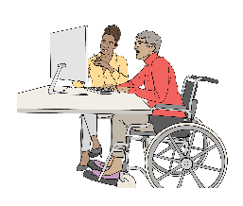
It is okay to ask someone to support you to do online survey.

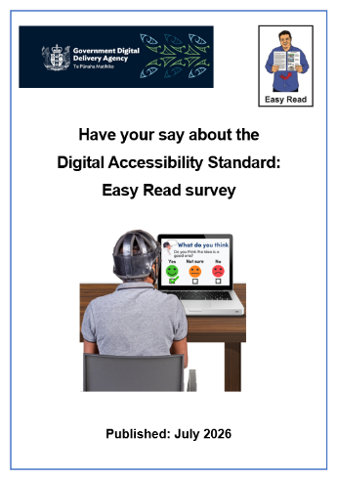
- There is Easy Read survey which is shorter with 10 questions.

The Easy Read survey is called:
Have your say about the Digital Accessibility Standard: Easy Read survey


You can find this Easy Read survey at:
www.digital.govt.nz/das#alt

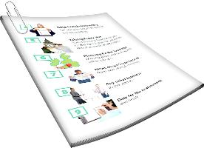
You can email us if you:
would like printed copies of the Easy Read sent to you
Have any questions about the DAS.
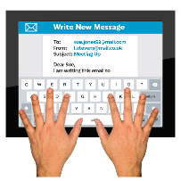
Our email is:

web.standards@gdda.govt.nz


This information has been written by the Government Digital Delivery Agency –
Te Pūnaha Matihiko.

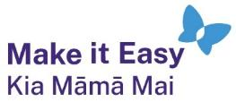
It has been translated into Easy Read by the Make it Easy Kia Māmā Mai service of People First New Zealand Ngā Tāngata Tuatahi.

The ideas in this document are not the ideas of People First New Zealand Ngā Tāngata Tuatahi.

All images used in this Easy Read document are subject to copyright rules and cannot be used without permission.

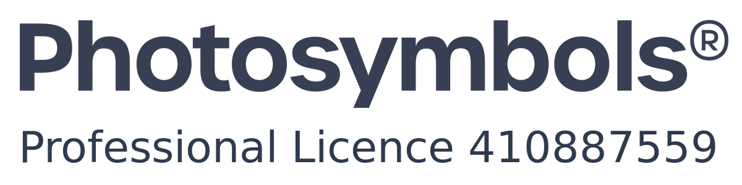
Make it Easy uses images from:

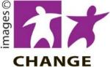
- Photosymbols

- Change Images


- Huriana Kopeke-Te Aho
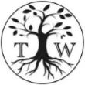
- SGC Image Works

- T Wood

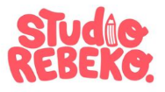
- Studio Rebeko

- Inga Kramer.

