The New Zealand API Standard

About this document
This standard was drafted using AI working from the three NZ API Guideline documents as structured datasets, guided by a digital regulatory infrastructure approach and manual review. The AI conducted systematic research across the source material and produced drafts with citations; a human reviewer then annotated, revised, and calibrated every provision. The full process, including raw search results, prompts, and review annotations, is described in a separate Transparency Hub.
Every normative statement in this document includes a DocRef link to the specific paragraph in the API Guidelines it is derived from. Some of the normative requirements have been modified to reflect feedback from agencies during the drafting process.
Once finalised, this standard is intended to replace the API Guidelines as the governing document. At this stage, the DocRef links are provided to support independent review during consultation, not as permanent cross-references in the final standard.
An MCP server is available to agencies responding to this consultation to support more rapid response and evaluation. It provides natural language query access to both this draft standard and the original API Guidelines, returning answers with citations to specific provisions. This can help reviewers compare the standard’s requirements against the source guidelines. Connection details and other downloadable datasets are available in the Disclosure Package on Gitlab and Google Drive.

About This Standard 4
Scope 4
Normative Language 5
How to Read This Standard 5
Definitions 6
Design 8
Design Approach 9
Co-design and Engagement 9
Resource Design 10
API Type Selection 11
Development 11
HTTP Requirements 11
Error Handling 12
Data Validation 12
Testing 13
Security 13
Transport Security 14
Authentication and Authorisation 14
Privacy and Security Assessments 15
Token Security 15
Deployment 16
Versioning 16
Documentation and Publication 17
Stability and Backwards Compatibility 17
Configuration and Release Management 17
Operations 18
Monitoring and Analytics 18
Throttling and Availability 18
Service Level Agreements 19
API Lifecycle Management 19
Governance 19
Deprecation and Retirement 20
Continual Improvement 20
Figure 1: Internal API security 22
Figure 2: Developer authentication to API access 23
Figure 3: Unidentified consuming application 23
Figure 4: Consuming application identification 24
Figure 5: System-to-system authorisation 24
Figure 6: Consuming application authorisation 25
Figure 7: Delegated authority 26
Figure 8: Decoupled flow 26

About This Standard
This standard establishes requirements and recommendations for New Zealand government agencies developing, deploying, and operating Application Programming Interfaces (APIs).
It formalises the New Zealand Government API Guidelines (2022) into a single normative specification, consolidating content from Part A (API Concepts and Management), Part B (API Security), and Part C (API Development).
The standard generally emulates the requirements of the API Guidelines, however some of the requirements are modified based on agency feedback and other relevant factors.
This standard is issued for consultation. Feedback is invited on the scope, structure, and calibration of requirements, including whether individual provisions are appropriately classified as mandatory (MUST), recommended (SHOULD), or optional (MAY).
Normative provisions are traced to their source in the API Guidelines through DocRef citations in the format (DocRef), enabling readers to consult the original guidelines for additional context. The API Standard will replace the guidelines once it has been approved, with the guidelines retained only for archival purposes.
This standard is itself published in DocRef format, enabling download and re-use as structured data in CSV or JSON, as well as pinpoint linking, annotation and tagging as required.

Scope
This standard applies to APIs developed by or on behalf of New Zealand government agencies for the purpose of enabling programmatic interaction between systems, whether for internal, partner, or public use.
This standard covers the design, development, security, deployment, and operation of APIs. It addresses REST APIs as the primary API type, but it may also be suitable for other types of APIs.
This standard does not generally cover:
- Network infrastructure or hosting platform requirements
- Detailed software development lifecycle practices beyond those specific to API development
- Sector-specific technical requirements (such as health sector FHIR standards).
Agencies should also refer to the New Zealand Information Security Manual (NZISM), the Protective Security Requirements (PSR), and other relevant standards published by the Government Chief Digital Office, which provide broader requirements that apply alongside this standard. Key GCDO standards that may be relevant include:
- Standard for information sharing with third parties with specific guidance on Māori data.
- The Digital Service Design Standard, which includes sections on security and privacy, and data and information stewardship.
- Guidance materials on Privacy (including Information Sharing and information sharing agreements, and specific sections on Public sector responsibility for privacy, including Māori/Crown/Treaty obligations), Security (refers to NZISM, Cloud Risk, and Protective Security) and Risk management (with specific pages on risk management for information systems).
- Guidance on Governance, with specific guidance on Digital Information Management, the Public Records Act and Data Information Management Principles (which also include detailed advice on the data lifecycle).
- Guidance on Managing Online Channels (which in some cases may include APIs).
- While less directly relevant, the materials on Cloud Services and risk assessment may also be relevant in some situations to API design, governance, maintenance and deployment.

Normative Language
This standard uses normative language as defined in RFC 2119:

- MUST and MUST NOT indicate absolute requirements or prohibitions. Compliance with these provisions is mandatory.
- SHOULD and SHOULD NOT indicate strong recommendations. There may be valid reasons in particular circumstances to deviate from these provisions, but the full implications must be understood and carefully weighed before doing so.
- MAY indicates a provision that is truly optional. Agencies may choose to follow or not follow this guidance based on their specific circumstances, without requiring justification.

RFC 2119 also defines RECOMMENDED as synonymous with SHOULD, and OPTIONAL as synonymous with MAY. This standard uses SHOULD and MAY consistently rather than RECOMMENDED and OPTIONAL.

Non-capitalised uses of “must”, “should”, “may”, and “recommended” carry their ordinary English meaning and do not indicate normative requirements.

How to Read This Standard
The standard is organised around key areas of consideration that occur throughout an API lifecycle. These are currently framed as:
1. Design.
2. Development.
3. Security and security testing.
4. Deployment.
5. Operations.
Issues associated with any area of consideration may occur at any time during API design.
Some areas of consideration for API development generally occur before others, but grouping requirements in this way should not be interpreted as creating a sequential process. In particular, security and governance considerations are relevant at all phases, including the design phase, and on an ongoing basis.
Each section of the standard contains requirements with normative statements expressed as individual paragraphs. These have been structured to allow for automated allocation of unique identifiers and pinpoint URLs. Where a requirement has multiple components, these are generally presented as ordered lists to enable direct reference.
The appendices provide supporting reference material including authentication patterns, specification examples, error handling codes, a glossary, and external references.

Definitions
This section defines terms used throughout this standard. Terms defined here carry their defined meaning wherever they appear.

API Types and Categories
API (Application Programming Interface) means a clearly defined interface that enables programmatic interaction between applications and systems, so that consuming applications need only understand the interface and do not need to understand the underlying technologies (DocRef).
Internal API means an API used solely within an organisation by known internal personnel (employees or contractors) (DocRef).
External API means an API used by customers or application developers who are outside the providing organisation (DocRef).
Partner API means an API used by business partners who are known to the providing organisation and with whom there is typically a contractual relationship (DocRef).
Public API (also “Open API”) means an API available to any party that can meet the provider’s access control requirements (DocRef).
System API means an API that provides access to data or functions held in backend or legacy systems, encapsulating the complexities of interacting with those systems (DocRef).
Process API means an API that composes system APIs to achieve a specific business purpose, enabling cross-system workflows (DocRef).
Experience API means an API designed for end-user-facing applications, optimised for specific user experience requirements (DocRef).

Roles
API provider means the organisation that owns the resource (information or functionality) exposed by the API (DocRef).
API developer means the person or organisation that builds the API, beginning with the interface specification (DocRef).
Application developer means a person or organisation that creates or adapts software to consume the API (DocRef).
API consumer means application developers, consuming applications, and the end users who use the API (DocRef).
Consuming application means software that uses the API to access the resources the provider offers (DocRef).

Components
API developer portal means a component that enables API providers to engage with, onboard, educate, and manage application developers, providing capabilities including registration, documentation, analytics, and examples (DocRef).
API gateway means the component (physical or virtual) through which APIs are offered to users. It hosts APIs and enforces access control policies. The API gateway acts as the policy enforcement point (PEP) (DocRef).
API manager means a component enabling an agency to control an API’s visibility and behaviour, typically exposed as a user interface to internal staff. It provides API registration, catalogue administration, and lifecycle management (DocRef).
API catalogue means a published directory of all APIs offered by an agency, including interface specifications and access guidance, enabling API discovery by application developers (DocRef).
Interface specification means a technical description and reference model for an API, used by application developers to understand the technical aspects of the API. Interface specifications should also be provided in a machine-readable format (DocRef).

Technical Terms
REST (Representational State Transfer) means an architectural style for designing networked applications that uses standard HTTP methods, is stateless, scalable, and cacheable (DocRef).
OpenAPI Specification means a standard, programming language-agnostic interface to REST APIs, enabling both humans and computers to discover and understand the capabilities of a service (DocRef).
Resource means information or functionality accessible through an API — anything that can be named and addressed via a URI (DocRef).
Endpoint means a specific URI where an API resource can be accessed and operations can be performed on that resource (DocRef).

Security Terms
Authentication means the process of verifying the identity of a user or application requesting access to an API (DocRef).
Authorisation means the process of determining what an authenticated user or application is permitted to do (DocRef).
OAuth 2.0 means the industry-standard authorisation framework that enables applications to obtain limited access to resources on behalf of a resource owner (DocRef).
OpenID Connect means an identity layer on top of OAuth 2.0 that enables authentication and provides standardised ways to verify user identity (DocRef).
API key means a random character string (at least 40 characters) used to authenticate a client application to an API (DocRef).
Access token means a credential used to access protected resources after successful authentication and authorisation (DocRef).
TLS (Transport Layer Security) means a cryptographic protocol for secure communications over networks (DocRef).
PKCE (Proof Key for Code Exchange) means an extension to OAuth 2.0 that provides additional security for authorisation code flows, particularly for public clients (DocRef).

Lifecycle Terms
Versioning means managing different versions of an API over time, with clear version indications for application developers (DocRef).
Deprecation means the process of retiring an old API version, with adequate notice to consuming applications (DocRef).
Breaking change means a change where any consuming application requires modification to work with the new version (DocRef).
Non-breaking change means a change where any message processed by the previous version will also be successfully processed by the new version (backwards compatible) (DocRef).
Service level agreement (SLA) means an agreement defining performance, availability, and other quality metrics for an API (DocRef).
Analytics — the capturing and reporting of API usage data, including take-up metrics, performance, and diagnostics (DocRef).
CIBA — Client Initiated Backchannel Authentication; an OAuth 2.0 grant type where authentication is delegated to a separate device via an out-of-band mechanism (DocRef).
Co-design — collaboration with application developers when designing the API interface (DocRef).
Continual service improvement — the ongoing process of evaluating and improving APIs based on metrics, feedback, and changing requirements (DocRef).
Design-driven development — an approach where the interface specification is written before coding begins (DocRef).
Idempotency — the property where an operation can be applied multiple times without changing the result beyond the initial application (DocRef).
JSON — JavaScript Object Notation; a lightweight data-interchange format (DocRef).
Lifecycle management — managing the full lifecycle of APIs from publication to retirement (DocRef).
MTLS — Mutual Transport Layer Security; two-way authentication where both client and server authenticate each other using certificates (DocRef).
Throttling — rate limiting to ensure all users can access an API within SLA bounds (DocRef).

Design
This section establishes requirements for API design. The requirements in this section apply before development begins and continue to inform decisions as APIs evolve.

Design Approach

Design-driven development
Agencies MUST take a design-driven approach when building APIs. (DocRef)
This means the API interface specification is created before development begins, ensuring proper consideration of the purpose, content, and interface design. The specification provides a known integration point that both the application developer and API provider can build to.

Specification-first development
Agencies MUST design the API interface specification before beginning development. (DocRef)
The specification SHOULD serve as the primary API documentation or reference. (DocRef) It SHOULD: 1. be created in abstract as a means of defining the API to be built, 2. be version-controllable.

Design for the user
Agencies MUST design APIs with the application developer as the primary user. (DocRef)
APIs SHOULD be developed as generically as possible to meet the basic needs of potential application developers. (DocRef)

Ease of use
APIs, along with associated onboarding and support processes, MUST have a process in place to ensure they are simple to understand and well described. (DocRef)
Development and delivery of APIs MUST proactively plan to enable application developers to discover and develop against those APIs. (DocRef)

Co-design and Engagement

Co-design with application developers
Agencies MUST have a process in place to evaluate how best to engage with the market and identify their potential application developer community. (DocRef)
Agencies SHOULD collaborate with the application developer community when designing the API interface. (DocRef)
Agencies SHOULD have a process in place to identify and limit assumptions about how application developers will interact with the API. (DocRef)
Co-design ensures the API meets the needs of its users. Application developers are a primary source of requirements, and working with them to define requirements and design the interface ensures the API will meet their needs.

Early and iterative release
Agencies MUST prioritise getting early, limited-capability releases out with clearly defined scope, to enable application developers to start building. Completeness is not the goal for initial releases. (DocRef)
Early releases MUST be tested and stable so as not to impede uptake. (DocRef)

Business process analysis
Agencies MUST perform business process analysis when designing an API, to ensure that API development is business-driven rather than technology-driven. (DocRef)
This analysis helps identify potential partners and use cases, including processes that:
- Cross organisational boundaries
- Involve multiple agencies or business partners
- Require data sharing or integration
- Support customer-facing services
- Enable automation or system-to-system interaction

Internal use as validation
Agencies SHOULD, where feasible, build APIs in parallel with an internal system that consumes them, to validate that the API is fit for purpose. (DocRef)
Building for internal use first, then exposing the API externally, ensures the design has been tested in a real integration context.

Resource Design

Resource granularity
APIs SHOULD be designed at the lowest practical level of granularity, because this makes each service simpler and allows them to be combined in ways that suit the application developer. (DocRef)
APIs SHOULD NOT require application developers to follow a specific sequence of consumption just because that is how the backend is configured. (DocRef)

Communication with application developers
Agencies MUST inform application developers about the thinking behind the API, including the resources to be exposed, the granularity of access, and capabilities to be offered. (DocRef)
Agencies SHOULD include roadmaps indicating the planned evolution of the API, so that developers have time to prepare for changes. (DocRef)

API Type Selection

Selecting API types
Agencies MUST have a process in place to evaluate and document which API type best matches their technical requirements. (DocRef)

Development
This section establishes technical requirements for implementing APIs. It must be evaluated and considered in light of other key areas of consideration in this standard.

HTTP Requirements

HTTP verbs
Access to any REST APIs MUST occur through the standard HTTP verbs in line with the IETF HTTP Semantics Standard and IETF Proposed Standard. (DocRef).

Content-Type header in responses
Response headers MUST contain Content-Type indicating the format of the response content (for example, Content-Type: application/json). (DocRef)
The Content-Type SHOULD also include the version of the API that processed the request (for example, Content-Type: application/json,version=1.1). (DocRef)

Content-Type header in requests
Requests that include a request body (PATCH, POST, PUT, DELETE) MUST include a Content-Type header. (DocRef)
The API MUST respond with HTTP status 415 (Unsupported Media Type) if the Content-Type is not supported by the server. (DocRef)

Accept header
APIs SHOULD support content negotiation through proper use of Accept headers, allowing clients to specify their preferred response formats. (DocRef)
The server SHOULD respond with HTTP status 406 (Not Acceptable) if the client requests a format the server cannot produce. (DocRef)

Error Handling

Error response requirements
Error responses MUST be both human-readable and machine-consumable. (DocRef)
Error responses MUST NOT leak sensitive information about the system implementation, internal structure, or data (DocRef), including: 1. Stack traces or internal error details 2. Database query information 3. Internal system paths or configuration details 4. Security credential information

Error response structure
Error responses MUST contain the following elements: (DocRef)
- An HTTP status code or equivalent indicating the general nature of the error
- An API-specific error code identifying the specific error condition, enabling programmatic handling
- A human-readable message providing a clear, actionable description of the error
Error responses SHOULD be consistent in format across all endpoints of an API. (DocRef)

HTTP status codes
APIs accessed via HTTP MUST use appropriate HTTP status codes to indicate the outcome of requests. (DocRef)

Data Validation

Input validation
APIs MUST validate all incoming data to ensure security and data integrity. (DocRef)
Validation SHOULD include: (DocRef)
- Secure parsing and strong typing to prevent injection attacks
- Content-Type validation against expectations
- JSON content validation against schema
- XML validation against schema and format, where XML is supported
- Scanning of uploaded attachments for malicious content

JSON as default format
APIs SHOULD use JSON as the default format for request and response payloads unless specific requirements dictate otherwise. (DocRef)
A JSON Schema SHOULD be used to define and validate data structures. (DocRef)

Machine-readable specifications
Interface specifications SHOULD be provided in a machine-readable format. (DocRef)
For REST APIs, agencies SHOULD use OpenAPI (formerly Swagger) as the interface specification language. (DocRef)

Testing

Test-driven development
Tests MUST be incorporated into the automated build process to provide early warning of regression failures. (DocRef)
API code MUST NOT progress through software development lifecycle (SDLC) environments until successful test execution has been achieved. (DocRef)
Tests can be written against the interface specification early in development by developing just enough API code to enable the test to be run (stubs).

Sandbox environments
Where APIs are for development or testing purposes, registration SHOULD be self-service and the ability for an application developer to try out the API should be provided. (DocRef)

Security
This section establishes requirements for securing APIs. Security must be considered on an ongoing basis and through the API lifecycle.

Early and Ongoing Security Evaluation
A security framework applicable to APIs MUST be defined at the organisation and business level as early as possible. (DocRef)
The security framework applied to an API MUST consider who, how, and what users and applications — both internal and external — will interact with the APIs. (DocRef)
Not all APIs require the same level of security. The security framework SHOULD be proportionate to the sensitivity of the data and operations it exposes. (DocRef)

Threat mitigation
APIs MUST implement mitigations for common threats, including: (DocRef)
- Exposure of inappropriate API methods — protect and limit the HTTP methods exposed; validate methods for session token or API key
- Denial of Service attacks — throttle access to exposed APIs; monitor use to detect possible attacks
- Malicious input, injection attacks, and fuzzing — validate input with secure parsing and strong typing; validate content types and content against schema; scan attachments
- Cross-site request forgery — use tokens with state and nonce parameters
- Cross-site scripting — validate input and sanitise output
Threat protection SHOULD be addressed at the operating system hardening level. (DocRef)
Threat protection MUST be an integral part of API software development. (DocRef)

Transport Security

TLS requirement
All communications to or from an API MUST be at least TLS 1.2 with strong ciphers, with TLS 1.3 preferred. (DocRef)
TLS implementations MUST use a cipher suite that includes DHE or ECDHE. (DocRef)
Other versions of TLS and Secure Sockets Layer (SSL) SHOULD be disabled. (DocRef)
Agencies MUST have a process in place to identify insecure TLS implementations and address them.

TLS implementation
The consuming application MUST validate the TLS certificate chain when making requests to protected resources, including checking the Certificate Revocation List (CRL). (DocRef)

Mutual TLS
For business-to-business and system-to-system interactions requiring high security, Mutual Transport Layer Security (MTLS) SHOULD be considered. (DocRef)
MTLS provides two-way authentication where both the client and server authenticate each other using certificates.

Authentication and Authorisation

Authentication
Where an API requires authentication, the API MUST identify the users or consuming applications that want to access it, and confirm that the party requesting access is who they say they are. (DocRef)
Authentication does not automatically authorise access to the APIs or the underlying resources.

Common authentication pattern
Agencies SHOULD use a common authentication and authorisation pattern, preferably based on existing security components. (DocRef)
Agencies SHOULD NOT create bespoke security solutions for each individual API. (DocRef)

OAuth 2.0
Agencies SHOULD evaluate whether OAuth 2.0 is appropriate for API authorisation.
Agencies SHOULD adopt different OAuth 2.0 grant types depending on API usage patterns.
- Authorisation Code Grant SHOULD be used for most scenarios involving user authorisation, particularly public-facing APIs. PKCE SHOULD be included in this flow. (DocRef)
- Client Credentials Grant SHOULD be used for system-to-system interactions without end-user context. (DocRef)
- Client Initiated Backchannel Authentication (CIBA) SHOULD be used for decoupled authentication flows where authentication is delegated to a separate device. (DocRef)
OAuth 2.0 provides a comprehensive and extensible approach to API authorisation based on security tokens. It is widely regarded as the industry standard for production-quality API security.

OpenID Connect
Agencies SHOULD use OpenID Connect where an OpenID Connect provider is available. (DocRef)
OpenID Connect is an authentication protocol based on the OAuth 2.0 framework that provides standardised ways to verify user identity.

API keys
Agencies SHOULD use API keys for all APIs, particularly for application identification and authentication. (DocRef)
API keys MUST be at least 40 characters in length. (DocRef)
All communications using API keys MUST be over TLS to protect the key in transit. (DocRef)

Authentication pattern selection
Agencies SHOULD evaluate whether the 8 distinct authentication patterns with detailed descriptions in Appendix A are appropriate for any given API system.

Privacy and Security Assessments

Privacy impact assessment
Agencies MUST consider at each stage of API development, from concept through to implementation, whether a privacy impact assessment or security risk assessment is appropriate. (DocRef)

Token Security

Token protection
Tokens MUST be protected both in transit (via TLS) and in storage (via encryption). (DocRef)
Token protection measures SHOULD include: (DocRef)
- Digital signing of tokens (for example, JWS with JWT) to prevent manufacture or modification
- Message Authentication Codes (MAC) for integrity
- TLS 1.3 with appropriate cipher suites to prevent disclosure in transit
- Encryption of tokens in storage
- Appropriate token lifetimes
Refresh tokens SHOULD have a maximum lifetime of 24 hours. (DocRef)

Deployment
This section covers how APIs are versioned, documented, published, and managed through their lifecycle. Effective deployment ensures APIs remain stable, discoverable, and maintainable.

Versioning

Evaluation of breaking changes
Agencies MUST have a process in place to evaluate whether development work creates breaking changes before any deployment.

Version indication
APIs SHOULD have a clear indication of the version, so that application developers can ensure they are using the appropriate version for their consuming application. (DocRef)

Header-based versioning
Agencies SHOULD use header-based versioning. (DocRef)
Header-based versioning SHOULD be performed using the Accept header, where a consuming application requests a specific version. This approach is considered the most RESTful because the resource path remains unchanged. (DocRef)
The response SHOULD indicate the version of the API that was called, via the Content-Type header or Location header. (DocRef)

URL-based versioning
URL-based versioning MAY be adopted as an acceptable alternative to header-based versioning.
For any URL-based versioning:
- The URI SHOULD include /vN with the major version number (N) and v as a prefix (DocRef)
- Agencies MUST NOT include minor version numbers in API URL paths (DocRef)

When to version
An API MUST be versioned when a change is a breaking change — that is, when any consuming application would require modification to work with the new version. (DocRef)
A breaking change MUST be treated as a major version change (for example, 1.3 to 2.0). (DocRef)
A non-breaking change SHOULD be treated as a minor version change (for example, 1.1 to 1.2). (DocRef)

Version maintenance
For major changes which are not backwards compatible, the old API version MUST be maintained alongside the new version for an appropriate period to allow all consuming applications to transition. (DocRef)

Documentation and Publication

API catalogue publication
Once an API is ready to be offered to users, the API definition SHOULD be published to an API catalogue. (DocRef)
An external API MUST be well documented and provide accurate, up-to-date guidance via the catalogue. (DocRef)
The catalogue SHOULD contain interface specifications and guidance on how to gain access and use the APIs, including the granularity of access control. (DocRef)

Machine-readable specifications
Interface specifications SHOULD be provided in a machine-readable format alongside the catalogue entry. (DocRef)

Stability and Backwards Compatibility

API stability
APIs MUST be available and work consistently. (DocRef)
APIs SHOULD support a velocity of change acceptable to application developers. (DocRef)
Early versions of APIs SHOULD be made available via pilots or developer portals so application developers can identify areas of instability before the API enters production. (DocRef)

Backwards compatibility
Agencies SHOULD handle regular change through good version control and proactive communication with application developers about changes that may affect them, including failures and outages. (DocRef)

Configuration and Release Management

Configuration management
All components that make up an instance of an API SHOULD be held within version control, so that it is possible to rebuild a previous version if necessary. (DocRef)
This includes the API interface specification and the associated API code.

Release management
The aim with API development SHOULD be to make small changes and release often. (DocRef)
Release management activities include planning API rollout, making small incremental releases, delivering frequently, and identifying issues early.

Operations
This section covers the ongoing management, monitoring, and improvement of APIs throughout their operational lifecycle.

Monitoring and Analytics

Usage monitoring
Agencies MUST monitor API usage to support decisions about deprecation, investment, and performance improvement. (DocRef)
Analytics SHOULD enable agencies to:
- Monitor uptake of API services
- Determine when to deprecate old versions
- Profile usage for business understanding and return on investment
- Profile usage to establish security baselines
- Detect and respond to security events

Performance analytics
Agencies SHOULD use performance analytics to ensure APIs meet SLAs and other commitments. (DocRef)
Performance metrics SHOULD include error rate, throughput, response time, and backend performance. (DocRef)

Throttling and Availability

Throttling
Agencies SHOULD implement throttling to ensure all users can access the API within SLA bounds. (DocRef)
Throttling MAY also include quota management, whereby consuming applications are given limited access (for example, a set number of calls per hour) to protect the API from abuse or overuse. (DocRef)

Service Level Agreements

SLA definition
APIs SHOULD have service level agreements defining performance, availability, and support commitments. (DocRef)
SLAs SHOULD be published in the API developer portal to set transparent expectations for API users. (DocRef)

SLA components
SLAs SHOULD define: (DocRef)
- Performance metrics — response time thresholds, throughput guarantees
- Availability metrics — uptime percentage, maintenance windows, maximum downtime
- Error rates — maximum acceptable error percentage
- Support commitments — response times for different severity levels, support hours, escalation procedures

API Lifecycle Management

Lifecycle governance
Agencies SHOULD manage APIs through their full lifecycle, from initial publication to retirement. (DocRef)
The standard API lifecycle includes service strategy, service design, service transition, service operation, and continual service improvement.

Consumer identification
Agencies SHOULD identify all application developers using their APIs, even where the API is considered public. (DocRef)
The ability to identify who is using an API is critical for lifecycle events such as deprecation notification and outage communication.
Agencies SHOULD maintain a registry of API users and establish communication channels with them. (DocRef)

Governance

API governance programme
Agencies with multiple APIs MUST establish an API governance programme. (DocRef)
API governance MUST evaluate and adopt as far as practicable: (DocRef)
- Style and pattern guidelines for consistent API design
- Reference to relevant technical standards
- A common security framework
- Lifecycle governance from publication to retirement
- Tracking and analytics for deployment, usage, and user management

Deprecation and Retirement

Deprecation process
Agencies SHOULD follow a structured deprecation process when retiring API versions. (DocRef)
API deprecation processes SHOULD include:
- Monitor usage patterns to assess appropriate timing
- Notify all users with adequate lead time
- Maintain old and new versions concurrently during transition
- Track migration progress
- Set a retirement date only after the majority of users have transitioned
- Decommission and remove the old version from the catalogue

Trimming unused capabilities
Agencies SHOULD remove API capabilities that are unused and are not likely to be used, based on analytics and usage data. This simplifies the API surface and reduces maintenance burden. (DocRef)

Continual Improvement

Ongoing evaluation
APIs SHOULD be continuously evaluated and improved based on performance metrics, user feedback, security developments, and evolving business requirements. (DocRef)

Appendix A: Authentication Patterns
Agencies should use a common authentication and authorisation pattern, preferably based on existing security components, rather than creating a bespoke solution for each API. (DocRef)
The following patterns are defined in the NZ API Guidelines. Each pattern identifies a scenario and the recommended authentication approach.

Pattern 1: Internal Use Only
Scenario: API used exclusively by internal agency applications or systems.
Recommended approach: Authorisation code grant type where practical, or leverage existing internal authentication providers.

Figure 1: Internal API security
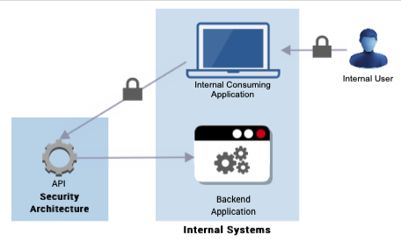
Internal API security.
Figure 1 shows there is the need to authenticate and authorise the internal user to the internal consuming application, and implement protection between the internal application and the API on the API gateway, which interacts with the backend application.

Pattern 2: Identifying an Application Developer
Scenario: Application developer authenticating to a developer portal for registration and API management.
Recommended approach: API gateway proprietary authentication.

Figure 2: Developer authentication to API access
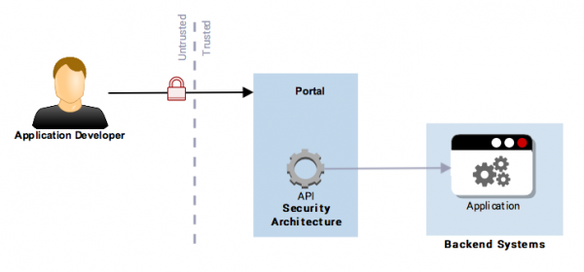
Application developer authentication is required to access and use the API.
Figure 2 shows that the application developer needs to be authenticated to the API developer portal to register their new application and attain the relevant credentials, which are used to secure interactions with the new application during development. The developer has to agree to the conditions of use, and subsequent usage of the API can then be traced via the API keys (see pattern 4: identifying a consuming application).

Pattern 3: Anonymous Consuming Application
Scenario: API provider does not need to identify which consuming applications are using the API.
Recommended approach: API keys.

Figure 3: Unidentified consuming application
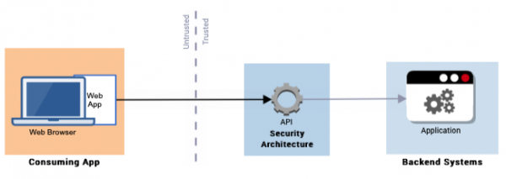
A consuming application that is unidentified but can still use an API.
Figure 3 shows a web application (the consuming application) on a web browser is unidentified (for example, has no API key) but can still use the API.

Pattern 4: Identifying a Consuming Application
Scenario: API provider needs to identify consuming applications for communication, logging, analytics, and usage tracking.
Recommended approach: API keys or API gateway proprietary.

Figure 4: Consuming application identification
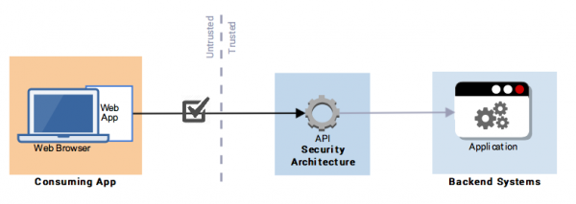
A consuming application is authenticated only for identification or registration purposes.
Figure 4 shows a web application (the consuming application) on a web browser is authenticated (for example, has an API key, client secret, and so on) to use the API, but this is only used as a means of identification or registration.

Pattern 5: Authorising a System-to-System Interaction (B2B)
Scenario: API used for information sharing or integration between systems, typically partner agencies or trusted business partners.
Recommended approach: OAuth 2.0 client credentials grant, Mutual TLS, API keys, or API gateway proprietary.

Figure 5: System-to-system authorisation
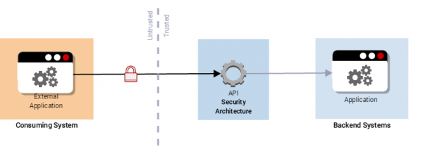
An external consuming system needs to be authenticated to access and use the API which often carries sensitive information.
Figure 5 shows an external application (the consuming system) needs to be authenticated to access the API.
In this model the aim is to ensure that only the correct consuming system has access to the API, and that the API is protected from malicious use. Business to business (B2B) models often carry sensitive information, so the consuming system needs to be authenticated to the provider for authorised access, confidentiality and integrity.

Pattern 6: Authorising a Consuming Application
Scenario: Different consuming applications are granted different levels of access based on the application itself, not the end user.
Recommended approach: OAuth 2.0 client credentials grant, API keys, or API gateway proprietary.

Figure 6: Consuming application authorisation
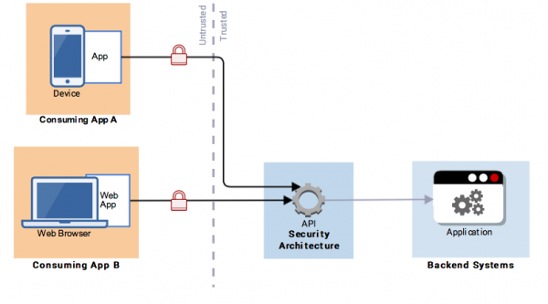
Different consuming applications need to be authenticated to access different levels of the API.
Figure 6 shows 2 consuming applications, an application on a smartphone (consuming app A) and a web application on a web browser (consuming app B). Both consuming applications must be authenticated and authorised before accessing the API. This is normally enforced at the API gateway.

Pattern 7: Authorising a Customer (Delegated Authority)
Scenario: Consuming applications are granted different access depending on which end user is using the application. The application acts on behalf of the authenticated user.
Recommended approach: OAuth 2.0 authorisation code grant, with or without OpenID Connect. PKCE SHOULD be included. CIBA with OpenID Connect is also suitable. (DocRef)

Figure 7: Delegated authority
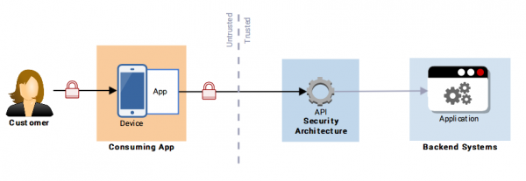
External consuming application is authorised to access different resources depending on the customer using the application.
Figure 7 shows the customer authenticates through the application (consuming application) on their smartphone device. The device and / or the application is already authorised to use the API. The customer logs in and authorises the device and / or application to access their information, for example, an internet banking application.
Pattern 8: Decoupled Flow — Client Initiated Backchannel Authentication (CIBA)
Scenario: Authentication is delegated to a separate device via an out-of-band mechanism, decoupling the authentication device from the consuming application.
Recommended approach: OAuth 2.0 CIBA grant type with OpenID Connect.

Figure 8: Decoupled flow
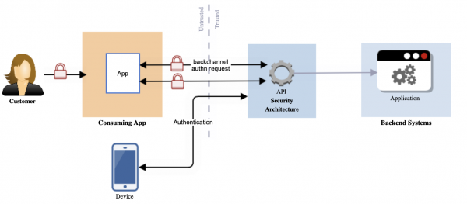
Authentication and consent process is delegated to authentication device of end user which decouples the device from the traditional flow.

Appendix B: API Specification Examples
Interface specifications should be provided in a machine-readable format. Agencies should use OpenAPI for REST APIs. (DocRef)

OpenAPI Specification
The OpenAPI Specification (formerly Swagger) provides a standard, language-agnostic interface to REST APIs. It enables both humans and computers to discover and understand the capabilities of a service.
An OpenAPI specification typically includes:
- API information — version, title, description, contact
- Servers — base URLs for different environments
- Paths — available endpoints and operations
- Components — reusable schemas, parameters, responses, security schemes
- Security — authentication and authorisation requirements

openapi: 3.0.0
info:
title: Example Agency API
version: 1.0.0
description: A sample API specification
servers:
- url: https://api.exampleagency.govt.nz/v1
description: Production server
- url: https://api-sandbox.exampleagency.govt.nz/v1
description: Sandbox server
paths:
/claims:
get:
summary: List all claims
responses:
'200':
description: Successful response
content:
application/json:
schema:
type: array
items:
$ref: '#/components/schemas/Claim'
post:
summary: Create a new claim
requestBody:
required: true
content:
application/json:
schema:
$ref: '#/components/schemas/ClaimInput'
responses:
'201':
description: Claim created successfully
components:
schemas:
Claim:
type: object
properties:
claimId:
type: string
format: uuid
description:
type: string
status:
type: string
enum: [DRAFT, SUBMITTED, PROCESSING, ACCEPTED, REJECTED]
createdDate:
type: string
format: date-time
ClaimInput:
type: object
required:
- description
properties:
description:
type: string
amount:
type: number
format: double
securitySchemes:
oauth2:
type: oauth2
flows:
authorizationCode:
authorizationUrl: https://api.exampleagency.govt.nz/oauth/authorize
tokenUrl: https://api.exampleagency.govt.nz/oauth/token
scopes:
read:claims: Read access to claims
write:claims: Write access to claims
security:
- oauth2:
- read:claims
- write:claims

Appendix C: References and Standards

Source Documents
NZ API Guidelines Part A: API Concepts and Management (2022)
NZ API Guidelines Part B: API Security (2022)
NZ API Guidelines Part C: API Development (2022)

NZ Government Standards and Guidance
New Zealand Information Security Manual
Protective Security Requirements
Digital Service Design Standard
Strategy for a Digital Public Service
Government Digital Standards Catalogue

Security Standards
RFC 2119 — Key words for use in RFCs to Indicate Requirement Levels
RFC 6749 — OAuth 2.0 Authorisation Framework
RFC 6819 — OAuth 2.0 Threat Model and Security Considerations
RFC 8446 — TLS 1.3
OpenID Connect Core Specification
OWASP Top Ten
OWASP API Security Top 10
OWASP REST Security Cheat Sheet

API Specifications
OpenAPI Specification

HTTP Standards
RFC 9110 — HTTP Semantics
RFC 5789 — HTTP PATCH

